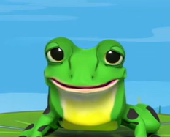
Yellow and Blue
Set 3 Word Challenge videos 1-10
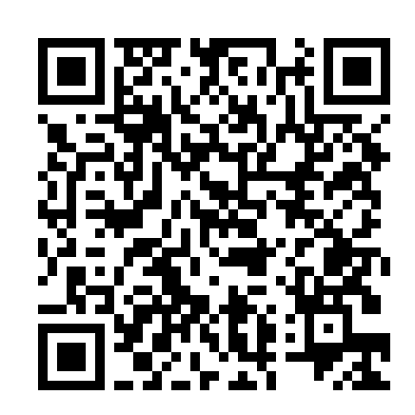
Yellow and Blue
Set 3 Word Challenge videos 1-10

