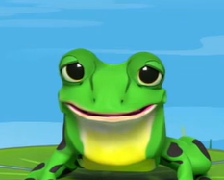
Green and Purple



Green and Purple

Word challenge videos 1-10
Set 2



Word challenge videos 1-10
Set 2

