Writing  This term, we will be continuing with narrative with our new book, Wisp – A Story of Hope. We will be revisiting using expanded noun phrases, including our prepositions and commas after fronted adverbials.  After, we will be looking at a non-fiction piece titled ‘Blue John’ where the children will be writing a letter to explain. We will be focusing on extending our sentences, using a varied vocabulary relevant to the context and organising our learning into paragraphs. |  |  | Reading  Over the term, we will learn how to comprehend a variety of fiction and non-fiction texts by using the VIPERS skills (vocabulary, interpreting, predicting, explaining, retrieving and summarising).  We will be focusing on books that will be linked to Vikings to support our History learning. |  | Maths  Our Maths this term is very varied! We will be learning about decimals – rounding them and placing them in order. Following on from this, we will be moving on to money – adding and subtracting.  Then, we will look at time and telling the time. If you’re able to, please have a chat with your child/ren at home to give them a head start. Shapes will follow time which will then feed in to statistics and position and direction. Once all of the objectives are covered, we will focus on recapping Place Value and Addition and Subtraction. |  |  |  | RE  Our main question in the first half of the summer term is ‘When Jesus left, What was the impact of the Pentecost?’ During this topic we will learn about the holy spirit. Our final RE topic of the year will be about how life can be seen as a journey and we will look at significant events that mark this journey.
Science  We will be looking at Living Things in Science. We will study Digestion which is always a fun topic, but it may get a little bit gross! We will look at our teeth, what they’re for and how to look after them. We will then conclude Science with studying food chains and their different elements. |  |  |  | Year 4 Summer  Curriculum Overview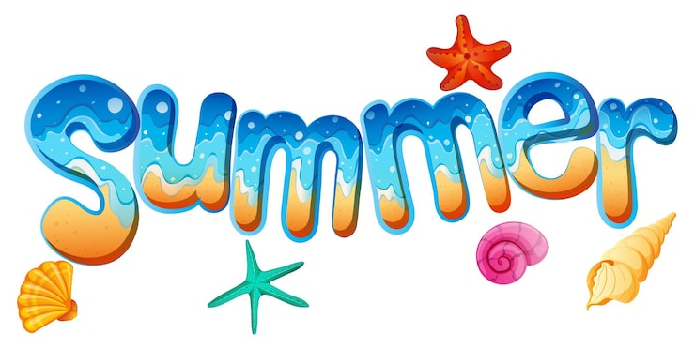 |  |  | History  During the second half of the summer term we will be learning about settlements and in particular focusing on the Anglo Saxons and the Vikings. We will be enquiring about why the Romans left Britain and the impact that they’ve had.  We will look into why the Anglo-Saxons and the Vikings raided one another and what they had hoped to achieve. After this, we will be learning about the first King of England, Alfred.
Music  In the summer term, we will be continuing to listen to different songs and appraising them. We will also build on our recorder knowledge by learning ‘Lean on Me’ on the recorder. | PSHCE  Through our Jigsaw scheme, we will learn about relationships and how we change as we get older. We will also continue to investigate how we learn through our learning behaviours and the importance of our school values. | Computing  In computing, we will learn about data logging. We will look at how and why data is collected. They will review and analyse data and pose questions in order to collect their own data. Later in the summer term, we will be taking photographs and investigating how these can be altered and used. |  |  |  | DT  Our Art and DT will be based around textiles. In Art, we will be studying the artist William Morris and using his work as an inspiration to create our own fabric design using batik. Then, in DT we will use the fabric to design and create a pencil case. We will learn about different sewing stitches and about seam allowances. |  | French  During the term, we will continue to recap and consolidate previous learning on numbers and food. Our main learning will be linked to learning time.. |  | PE  Our sports for the summer term will be tennis, rounders and athletics. We will be going to Plainmoor swimming pool to have swimming sessions, as well as having another outdoor activity.


