
Word challenge videos 1-10
Set 2

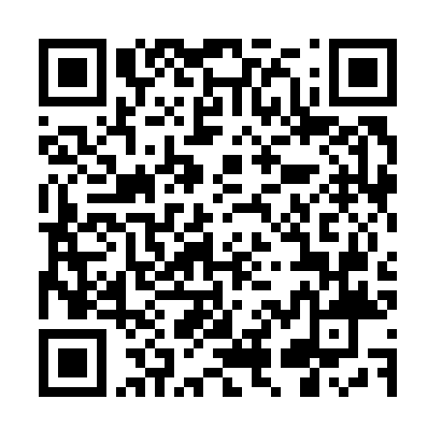

Word challenge videos 11-15
Set 2
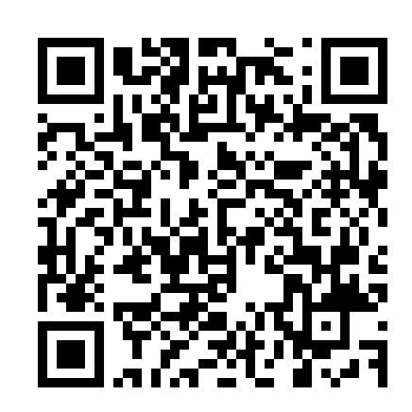

Word challenge videos 1-10
Set 3
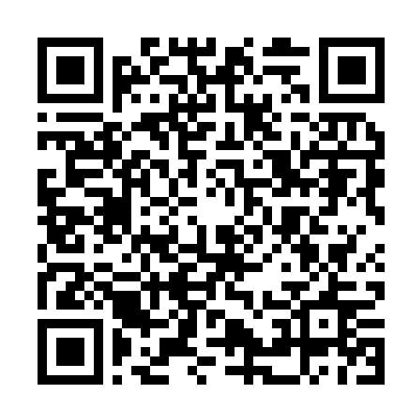

Word Challenge videos 11-20
Set 3

