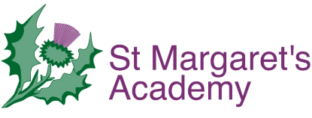

Teacher of the Deaf Person Specification

Qualifications: | E- Essential  D- Desirable
Degree or equivalent | E
Qualified Teacher Status | E
Mandatory qualification as a Teacher of the Deaf (TOD) or currently working towards this. | E

Knowledge and Experience: | E- Essential  D- Desirable
Current experience of teaching/supporting children and young people with a range of hearing impairments | E
Proven knowledge of and experience with EYFS, Key Stage 1 and 2 | E
Knowledge of and experience with Key Stage 3 and 4 | D
Good working knowledge of the National Curriculum requirements | E
Knowledge of how to promote the language development and educational attainment of a deaf pupil within a mainstream setting | E
Experience of using sign language within the educational setting | E
Knowledge and experience of a range of adaptive and augmentative technologies and strategies to promote inclusive opportunities for pupils with sensory impairments | E
Knowledge of a range of alternative methods of communication (e.g. Cued speech) | D
Experience of target setting and writing Individual Learning Plans (ILP’s) | E
Experience of statutory assessment and annual review meetings. | E
Experience and expertise in managing personal hearing aids, cochlear implants and radio aid systems on a daily basis. | E
Experience of multi-agency working | E
Experience of working with parents and carers | E
Experience of teaching deaf pupils in a variety of settings | D
Experience of mentoring and supervising others | D

Skills and Attributes | E- Essential  D- Desirable
Ability to professionally communicate clearly and effectively with children and young people, parents and carers. | E
An ability and commitment to relate positively to schools, other agencies and voluntary sector organisations. | E
Excellent interpersonal skills | E
Ability to work to deadlines and handle pressure | E
Ability to deliver training | E
Good IT skills | E
Have a positive “can do” attitude to innovation and change | E
Self-motivated and able to work efficiently and effectively with minimal supervision | E
Excellent organisational skills | E
Be ambitious and have a commitment to your own professional development | E
Be able and willing to contribute positively to the wider life of the school and working collaboratively with other settings in conjunction with St Margaret’s. | E

