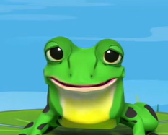
Red/Ditty
Set 2 sounds and word challenge videos
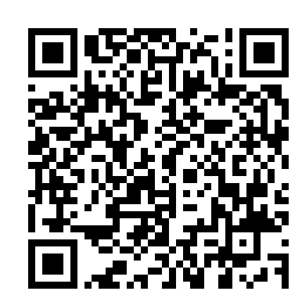

Red/Ditty
Set 2 sounds and word challenge videos

